SSY130 – Hand in 3

Target Tracking Using the Kalman Filter

Haitham Babbili

December 20, 2019

student id: 19880803

secret key: 'Lunala'

**Task 1.**

Given the state in the target motion model is given by:

$$s(t)=\left[\begin{matrix}s_{1}(t) \\ s_{2}(t) \\ s_{3}(t) \\ s_{4}(t)\end{matrix}\right]=\left[\begin{matrix}x(t) \\ \dot{x}(t) \\ y(t) \\ \dot{y}(t)\end{matrix}\right]$$

Apply the finite-difference approximation

${\dot{x}(t)|}_{t=kT}≈\frac{(kT+T)-x(kT)}{T}$

Our goal to run equation like:

$$s\left(k+1\right)=As\left(k\right)+w\left(k\right)$$

$$z\left(x\right)=C s(k)+ y(k)$$

We can drive the discrete space formulation by solving finite-difference approximation in stat target model equations, so we get

$x(k+1)-x(k)= T v_{x}(k)$, $x\left(kT+T\right)-x\left(kT\right)=Tv_{x}\left(k\right)$ (1).

$v_{x}(kT+1)-v_{x}(k)= 0$, $v_{y}\left(k+1\right)-v_{y}\left(k\right)=0$ (2).

From (1) we can find $$s\left(k+1\right)=As\left(k\right)+w\left(x\right)$$

Where. $A = \left[\begin{matrix}1 & T & 0 & 0 \\ 0 & 1 & 0 & 0 \\ 0 & 0 & 1 & T \\ 0 & 0 & 0 & 1\end{matrix}\right]$, w(k)= w ~ N(0,Q)

From (2) we can find $$z\left(x\right)=C s(k)+ v(k)$$

Where. C $= \left[\begin{matrix}1 & 0 & 0 & 0 \\ 0 & 0 & 1 & 0\end{matrix}\right]$, v(k)= w ~ N(0,R)

Where Q is the variance of w(k) and R is the variance of v(k).

**Task 2.**

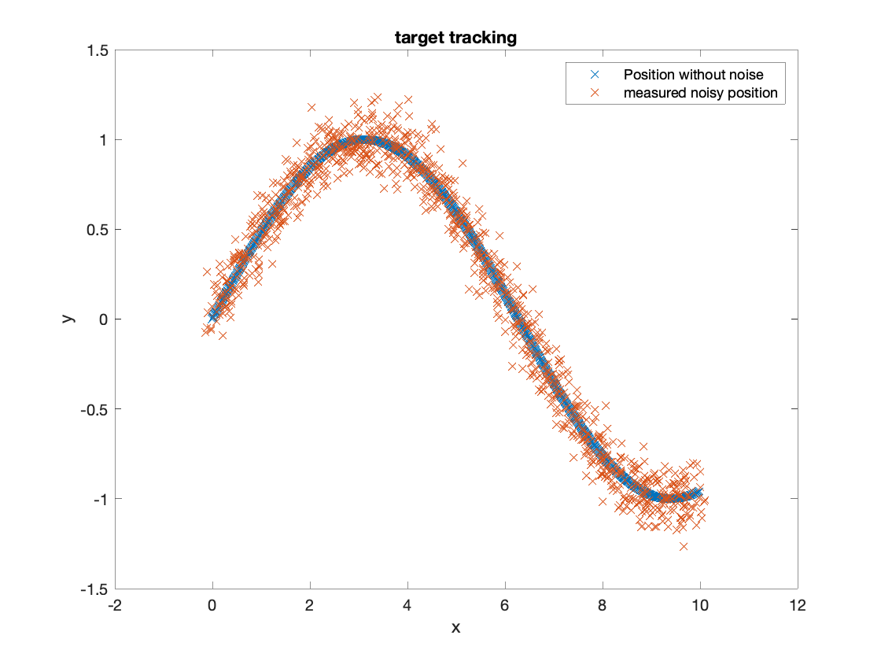Our task her is to show the input X agents the output Y with and without noise by using Kalman filter.

Figure 1. Measured vs Noise-free position

**Task 3.**

for t=1:N

% Filter update based on measurement

% Xfilt(:,t) = Xpred(:,t) + ...

Xfilt(:,t) = Xpred(:,t) + P*C'*inv(C*P*C' + R)*(Y(:,t) - C*Xpred(:,t));

% Uncertainty update, from (11.17)

Pplus = P - P*C'*inv(C*P*C' + R)*C*P;

% Prediction, from (11.19)

Xpred(:,t+1) = A * Xfilt(:,t);

% From (11.20)

P = A*Pplus*A' + Q;

end

**Task 4.**

To apply Kalman we need matrix of P0, Q and R. We will initiate covariance matrix $P0 = {10}^{6}. I$.We have given that the zero vector as initial vector

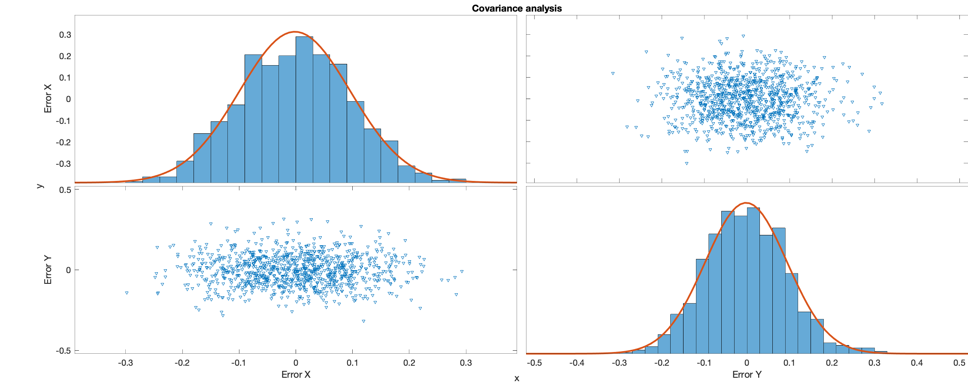If we say also that R is the prediction and Q is the noise and they are uncorrelated. So they are diagonal and ever element correspond to one value. As shown in figure below X related to covariance matrix R and Y to error

Figure 2. Covariance analysis to error of X&Y

Since N(0,R) we get:

$$R= \left[\begin{matrix}σ_{x}^{2} & 0 \\ 0 & σ_{y}^{2}\end{matrix}\right]=\left[\begin{matrix}9.7*{10}^{-3} & 0 \\ 0 & 9.7*{10}^{-3}\end{matrix}\right]$$

On other hand, Q is relevant to the covariance of noise process. But in our case, we can’t find any direct way to get value of Q matrix. So, depending in our provision assumption we create $∝$ as parameter:

$$Q=\left[\begin{matrix}0 & 0 & 0 & 0 \\ 0 & σ_{vx}^{2} & 0 & 0 \\ 0 & 0 & 0 & 0 \\ 0 & 0 & 0 & σ_{vy}^{2}\end{matrix}\right]= ∝ . \left[\begin{matrix}0 & 0 & 0 & 0 \\ 0 & 1 & 0 & 0 \\ 0 & 0 & 0 & 0 \\ 0 & 0 & 0 & 1\end{matrix}\right]$$

Where $∝$ is changeable parameter which determine the performance of Kalman filter. We can see deferent plot of Kalman position and velocity tracking with deferent value of .

1. 2.

3. 4.

**Figure. 3** position tracking for Kalman filter

From figure.3 we can see that, different value to alpha show as the effect of it for tracking the position tracking and velocity tracking., which is has little effect on position tracking.

After many tests found alpha is approximately 10-3 as in figure below.

I should mention that, tacking the derivative of the noisy signal without using Kalman filter the result will be very bad.

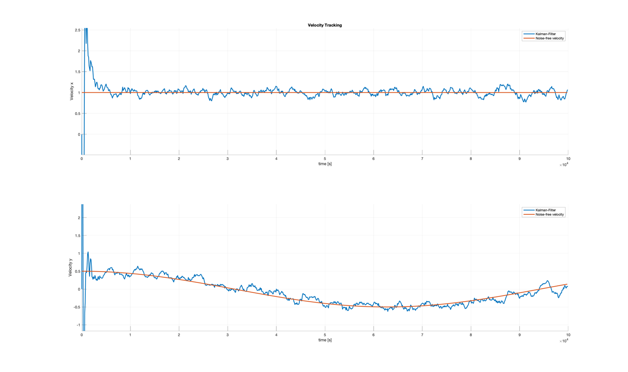

a)

b)

c)

**Figure 4**. variance of velocity tracking with changing of $∝$